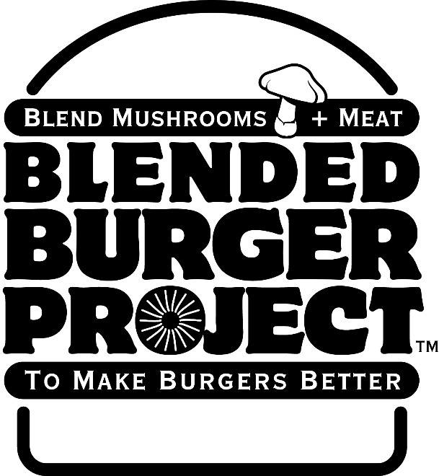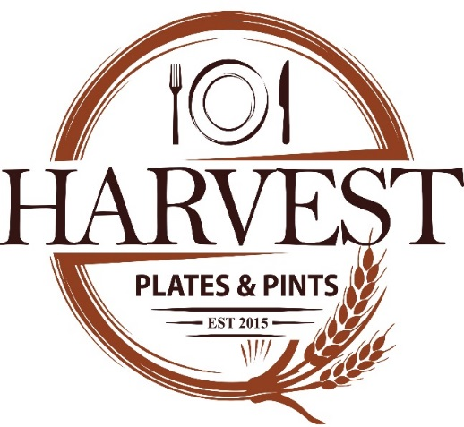

ANNOUNCES PARTICIPATION IN
THE JAMES BEARD FOUNDATION’S BLENDED BURGER PROJECT™
Harvest Plates & Pints has announced today that it will be participating in The James Beard Foundation’s (JBF) Blended Burger Project™, a nationwide initiative that challenges chefs to make a "blended burger" by blending ground meat* with finely chopped mushrooms to create a delicious, healthier, and more sustainable burger.
Chef Tom Hughbanks has chosen to feature “Banh Mi Pork Burger” $10 to highlight a healthier burger, from May 27, 2019 through July 31, 2019. Blending meat with mushrooms reduces calories, fat, and sodium while adding important nutrients like vitamin D, potassium, and B vitamins. A blended burger also brings more sustainable, plant-based items to menus allowing Americans to enjoy the taste and flavor of the burgers they love, knowing it is a healthier and more sustainable preparation.
Diners can vote and support the Blended Burger Project™:
- Visit jamesbeard.org/blendedburgerproject to view the gallery of blended burger photos, and cast your vote for the blended burger that best represents the most creative use of mushrooms, best flavor profile, and most appetizing appearance
- You can also visit a participating restaurant from May 27, 2019 – July 31, 2019 (view the entire list at jamesbeard.org/blendedburgerproject/participants) and ask for the “blended burger”.
- Post your burger photos to social media with the hashtag #blendedburgerproject to spread the word.

About the James Beard Foundation (JBF)
The James Beard Foundation’s mission is to celebrate, nurture, and honor chefs and other leaders making America’s food culture more delicious, diverse, and sustainable for everyone. For more than 30 years the Foundation has accomplished this mission through programs that highlight food’s central role in our lives. In addition to hosting guest-chef dinners throughout the year at the historic James Beard House in New York City, the Foundation administers the James Beard Awards; grants scholarships for culinary students; produces national events that include our Taste America tour; and creates educational programs for the culinary community and food lovers. The Foundation addresses the growing challenges facing our food system through its Impact Programs, which include the Leadership Awards; Chefs Boot Camp for Policy and Change; Issue Summits; and Culinary Labs. Industry issues, such as gender imbalance and diversity in culinary leadership, are addressed through our Industry Programs. For more information, please visit jamesbeard.org and follow @beardfoundation on Instagram, Twitter, and Facebook.

